Alberta’s 2021 Nutrition Report Card on Food Environments for Children & Youth is here!

This communications toolkit includes the following resources:
- Key messages
- Quotes
- Social media images and sample posts
- Infographic
- Email
- Article
- Media release

As one of our valued stakeholders who are committed to giving kids a better food environment, we encourage you to use any of the following resources to share our 2021 Nutrition Report Card with your networks. The report is available here: https://abpolicycoalitionforprevention.ca/evidence/albertas-nutrition-report-card/

For more information contact Dr. Kim Raine.

Key Messages

The 2021 Nutrition Report Card on Food Environments for Children and Youth gave Alberta a “D”. The seventh and final annual assessment shows that kids’ health needs a green light by creating food environments where the healthy choice is the easy choice, especially as food environments have never rated lower than now during these uncertain times. The pandemic has shown that heroic public policies can be taken to protect the health of citizens in time of need.
Poor diet is second only to smoking as a risk factor for premature death. That's why we need to pay attention to healthy eating and protect our children and youth from the invisible pandemic, diet-related chronic diseases.

The report covers various recommendations for schools, childcare settings and public buildings and this year includes data gathered by individual communities across Alberta. As the project comes to a close, the legacy will live on with online learning modules and an app to empower communities to make improvements on their own food environments.

Quotes

“Kids eat what’s available to them, what’s affordable and readily accessible.”

“It’s time for us to pay attention to the data about the invisible pandemic of diet-related chronic diseases, including heart disease, diabetes and some cancers. Poor diet ranks second only to tobacco as a risk factor for premature death in Canada.”
“Prevention requires improving food environments and ensuring there’s an opportunity for kids to make healthy choices. It’s something that we’re all responsible for — parents are trying to do their best within the constraints of these environments.”

“I think there is an assumption that it’s up to kids and parents to make the right choices. But if you take your kids to play hockey and the only snack that’s available is chips and pop, there’s no healthy choice.”

“We need to stop taking chronic diseases for granted and pay attention to how we can protect ourselves and our kids, just like we pay attention to the cases of COVID-19 during the visible pandemic.”

“The limits that were placed on people during COVID-19 brought the grade down to a D in 2021 — the general trend is mediocre and worsening.” — Kim Raine, Distinguished Professor in the School of Public Health and co-author of the 2021 Nutrition Report Card on Food Environments for Children & Youth
Social Media

Facebook

Alberta’s 2021 Nutrition Report Card on Food Environments for Children & Youth has been released! How did Alberta score? Read the report and learn how to support giving kids’ health a green light: https://bit.ly/30kJbqA

Another year and another failing grade. Our poor Nutrition Report Card grade means that even though there is no vaccine against premature chronic disease, supporting healthy food choices is something we all can do: https://bit.ly/30kJbqA

Poor diet is second only to smoking as a risk factor for premature death. That's why kids’ health needs a green light to protect our children and youth from the invisible pandemic, diet-related chronic diseases. More info: https://bit.ly/30kJbqA

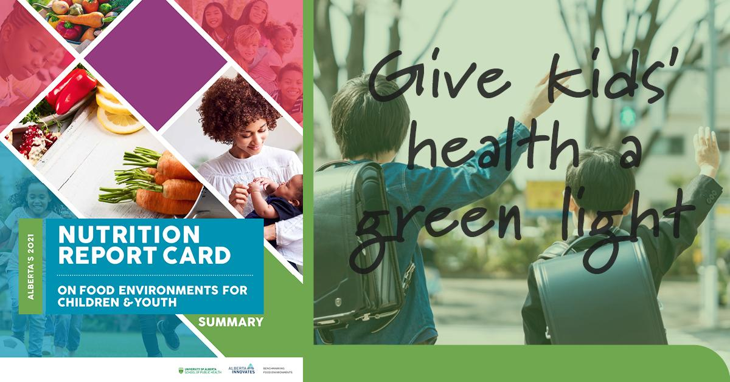
Image not to size

Twitter

- The 2021 #NutritionReportCard has been released! #AB needs to start making kids’ health the priority. More info: https://bit.ly/30kJbqA #PublicHealth
- Another year and an even lower score for our overall #nutrition grade for kids in #AB. We need to make some changes to raise that grade and make health policies top priority: https://bit.ly/30kJbqA #PublicHealth
- Poor diet is second only to smoking as a risk for premature deaths. That's why we need to pay attention to healthy eating and protect our children and youth from the invisible pandemic of diet related chronic diseases. Find out more in our #NutritionReportCard: https://bit.ly/30kJbqA #PublicHealth
- Poor nutrition grades in #AB means that even though there is no vaccine against premature chronic disease, changing our environments that promote unhealthy foods is something we all can do #AB #NutritionReportCard: https://bit.ly/30kJbqA
- Protecting our children and youth from the invisible pandemic (chronic disease) requires making healthy food affordable and accessible to raise our failing #NutritionReportCard grade: https://bit.ly/30kJbqA #PublicHealth

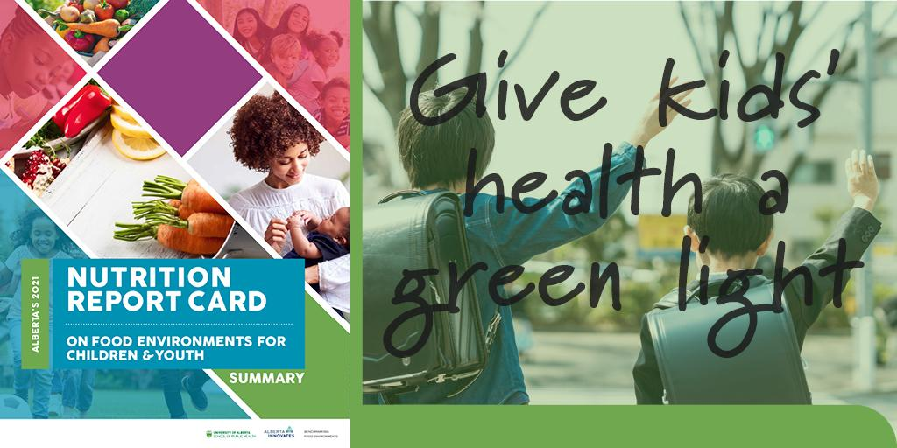
 | 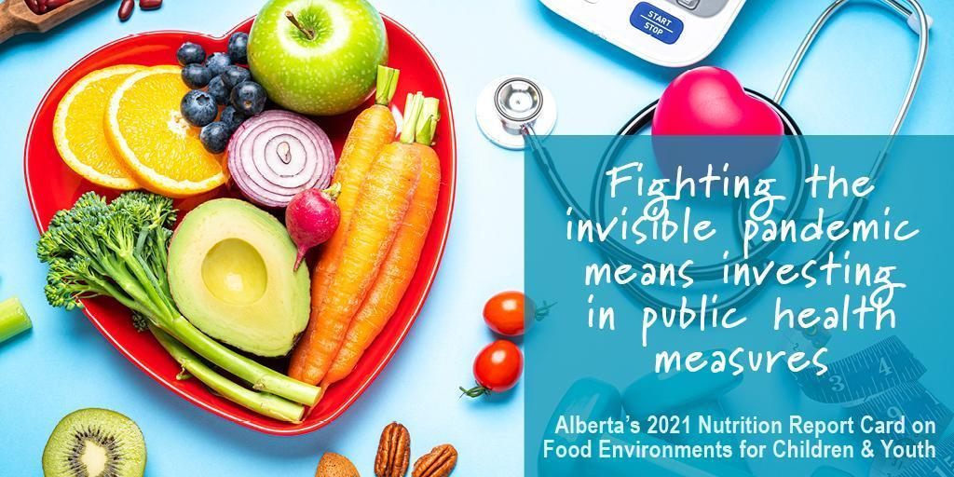
 | 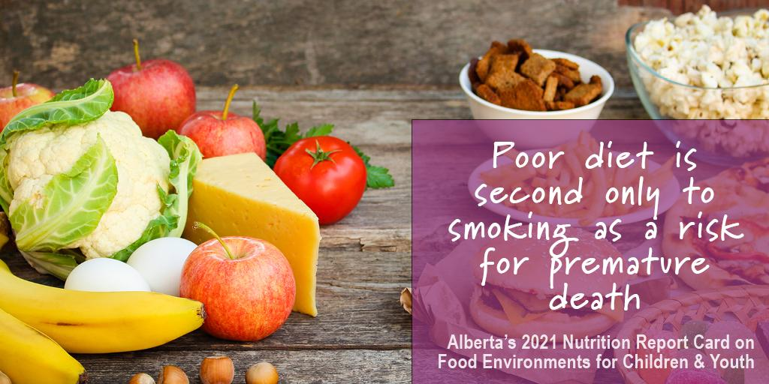
Images not true to size

Infographic

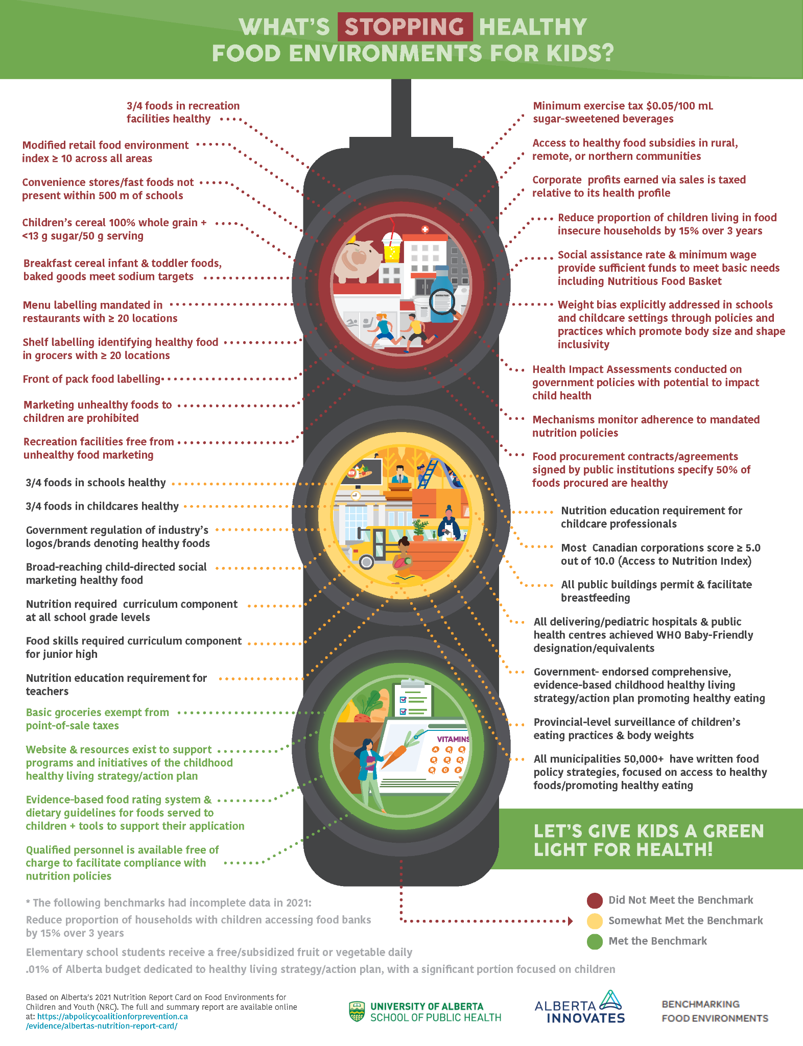Image not true to size
Email

Subject: Alberta’s 2021 Nutrition Report Card on Food Environments for Children and Youth

Alberta gets a “D” on its Final Nutrition Report Card for Kids
Alberta’s score for our seventh and final Nutrition Report Card on Food Environments for Children and Youth was a “D”.
Food environments have never been more threatened.
“Some of the challenges in providing healthy food faced by schools and childcare centres during COVID-19 brought the grade down to a D in 2021 — the general trend is mediocre and worsening,” said Dr. Kim Raine, distinguished professor in the School of Public Health and co-author of Alberta’s Nutrition Report Card on Food Environments for Children and Youth.
Kids eat what’s available to them, what’s affordable and readily accessible.
“I think there is an assumption that it’s up to kids and parents to make the right choices. But if you take your kids to play hockey and the only snack that’s available is chips and pop, there’s no healthy choice” explains Raine.
The silver lining of the pandemic is that there has been a shift to making public health top priority. Heroic measures were put in place to keep people safe and informed. The same thing can and needs to apply to diet-related chronic diseases.
“It’s time for us to pay attention to the data about the invisible pandemic of diet-related chronic diseases, including heart disease, diabetes and some cancers,” explains Raine. She also pointed out that a poor diet is second only to smoking as the top behavioural risk factor for premature mortality in Canada.

The report covers various recommendations for schools, childcare settings and public buildings and this year included data gathered by individual communities across Alberta. That way communities could be empowered to think about their own environments and strategies to improve them.
.
As the project comes to a close, the legacy to give the green light for kids’ health will live on with online learning modules and an app to empower communities to make improvements in their own food environments.
The annual nutrition report card was funded by Alberta Innovates and prepared in partnership with the Alberta Policy Coalition for Chronic Disease Prevention, which has 16 member organizations including Alberta Health Services, the Canadian Cancer Society and the Heart and Stroke Foundation.

Read the report at: https://abpolicycoalitionforprevention.ca/evidence/albertas-nutrition-report-card/

Article | newsletter, blog, or e-bulletin

Kids’ health needs a green light

Another year has passed and the pandemic is still not in our rearview mirror. This has been felt in many different areas including our food environments.

Everyone’s daily routines took a dramatic turn last year and they haven’t stabilized for a lot of families. For many children this past year meant eating more poorly, increasing the potential for chronic disease and further putting them at risk for COVID-19.

“It’s time for us to pay attention to the data about the invisible pandemic of diet-related chronic diseases, including heart disease, diabetes and some cancers. Poor diet ranks second only to tobacco as a risk for premature death in Canada,” explains Dr. Kim Raine, distinguished professor in the School of Public Health and co-author of Alberta’s Nutrition Report Card on Food Environments for Children and Youth.

The Nutrition Report Card was recently released, and Alberta received an overall score of “D” which is the lowest score in five years. “Some of the challenges in providing healthy food faced by schools and childcare centres during COVID-19 brought the grade down to a D in 2021 — the general trend is mediocre and worsening,” said Raine.
The seventh annual and final assessment shows that we need to give the green light and make the food environments around our young children a priority.
“I think there is an assumption that it’s up to kids and parents to make the right choices. But if you take your kids to play hockey and the only snack that’s available is chips and pop, there’s no healthy choice.” Basically, kids eat what’s available to them, what’s affordable and readily accessible.
There was a silver lining seen throughout the pandemic. “We learned during COVID that heroic measures can be taken to protect the health of the population,” Raine said. “We need to stop taking chronic diseases for granted and pay attention to how we can protect ourselves and our kids, just like we pay attention to the cases of COVID-19 during the visible pandemic.”
The report covers various recommendations for schools, childcare settings and public buildings and this year included data gathered by individual communities across Alberta. That way communities could be empowered to think about their own environments and strategies to improve them.
As the project comes to a close, the legacy to give the green light for kids’ health will live on with online learning modules and an app to empower communities to make improvements on their own food environments.
The annual nutrition report card was funded by Alberta Innovates and prepared in partnership with the Alberta Policy Coalition for Chronic Disease Prevention, which has 16 member organizations including Alberta Health Services, the Canadian Cancer Society and the Heart and Stroke Foundation.

Read the report at: https://abpolicycoalitionforprevention.ca/evidence/albertas-nutrition-report-card/

Media Release

COVID-19 underscores need to address ‘invisible pandemic’ of diet-related chronic diseases: researcher

Alberta Nutrition Report Card on Food Environments for Children and Youth suggests policies to support healthier food choices and improve population health.

The COVID-19 pandemic has brought to light both weaknesses and opportunities in the way public policies can support children’s long-term health, according to the seventh and final Alberta Nutrition Report Card on Food Environments for Children and Youth, released today.

“Kids eat what’s available to them, what’s affordable and readily accessible,” said principal investigator Kim Raine, distinguished professor in the University of Alberta’s School of Public Health.

“It’s time for us to pay attention to the data about the invisible pandemic of diet-related chronic diseases, including heart disease, diabetes and some cancers,” Raine said. “Poor diet ranks second only to tobacco as a risk for premature death in Canada.”

The COVID-19 pandemic has made it harder for children to eat well, partly because school lunch programs and daycare meals were interrupted, Raine said, and children who eat poorly are at higher risk for severe disease if they contract the virus.

“The limits that were placed on people during COVID-19 brought the grade down to a D in 2021 — the general trend is mediocre and worsening,” Raine said of the report's findings.

At the same time, the pandemic highlighted the potential to make a difference with nutrition-focused public health policies. “We learned during COVID that heroic measures can be taken to protect the health of the population,” Raine said.

“We need to stop taking chronic diseases for granted and pay attention to how we can protect ourselves and our kids, just like we pay attention to the cases of COVID-19 during the visible pandemic.”

Healthy eating: more than an individual choice

The nutrition report card assesses 40 evidence-based benchmarks to gauge the strength of policies and actions that affect how food is promoted, priced and sold to families in Alberta — such as the concentration of fast-food restaurants, how much new teachers learn about nutrition and whether breastfeeding is encouraged in public settings. All contribute to the food “environments” where children are raised and establish lifelong eating habits.

“I think there is an assumption that it’s up to kids and parents to make the right choices,” she said. “But if you take your kids to play hockey and the only snack that’s available is chips and pop, there’s no healthy choice.”

Public policies ranging from health promotion campaigns to food labelling requirements can help support better individual choices, Raine said, because there are no vaccines against premature chronic diseases.

“Prevention requires improving food environments and ensuring there’s an opportunity for kids to make healthy choices,” she said. “It’s something that we’re all responsible for — parents are trying to do their best within the constraints of these environments.”

Communities at the table

For the first time, the 2021 nutrition report card included data gathered by individual communities across Alberta, including Lethbridge, which reviewed the beverages, food and signage in its public recreation centres.

Representatives of town and city councils, schools, child care centres, civic organizations and health professionals came together to measure local food environment factors, and then the U of A team provided analyses and co-created community-specific recommendations, such as changing vending machine menu options or adding signage to encourage healthy choices.

As a legacy of the project, online learning modules and an app are now in development that would allow communities to continue making improvements on their own.

“The idea is to take out the middle people, so community members can be the citizen scientists to assess and think about their own environments and strategies,” Raine said.

The annual nutrition report card was funded by Alberta Innovates and prepared in partnership with the Alberta Policy Coalition for Chronic Disease Prevention, which has 16 member organizations including Alberta Health Services, the Canadian Cancer Society and the Heart and Stroke Foundation.
-30-

To see the report and learn more, please visit the Alberta Policy Coalition for Chronic Disease Prevention.

To arrange an interview with Professor Kim Raine, please contact:

Gillian Rutherford
Communications Advisor
University of Alberta
grutherf@ualberta.ca
587-988-7805

